**PEP/5K ZOOM Dry Run**

We will be holding a Virtual Zoom PEP meeting on 4/6. Zoom allows parents to listen to the meeting audio and see also video if their device allows it. *You do not need the Zoom app or a Zoom account to participate*.

We need PEP and 5K team members to help us conduct a dry run on 4/2 to 1) ensure that we understand system functionality, 2) validate the accuracy of the login directions, and 3) troubleshoot potential issues. Your help is greatly appreciated!

Here are the directions to attend the online PEP meeting through Zoom.

* Participants who have signed up via Track it Forward will be emailed the Zoom link by 3:00p.m. on Thursday, April 2nd. This notification will be sent to the email address affiliated with your Track it Forward account, so if you would like it sent to a different address please log into TIF and update your email address.
* In order to maintain security please do not forward the invitation link to other parents.
* From your smartphone, iPad, or computer click on the meeting link (located below the words Join Zoom Meeting) to access Zoom.
  + 
* You will see the following screen. If you have downloaded the Zoom app you will be prompted to open it. If you do not have the Zoom app, click the link at the bottom that says “Start From your browser.”

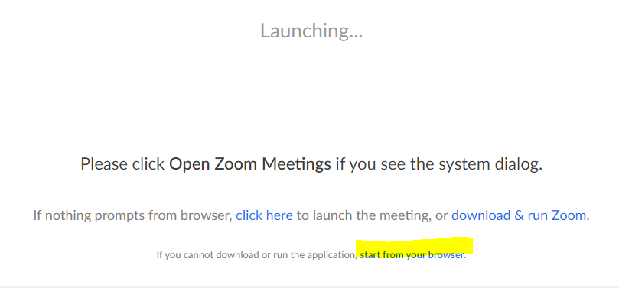

* You’ll be prompted to join the audio. Choose Join Audio by Computer
  + 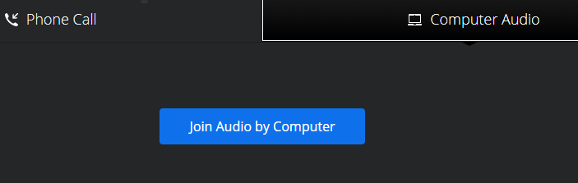
* From there you will be prompted to allow Zoom to use your audio and video. You are not required to use video to participate in the meeting, though that will enable you to see the speakers.
* If you’re having trouble logging on, please check with your student(s) as they are using Zoom in their classes.